CONFIGURE YOUR MICROSOFT SEBTINEL WORKSPACE

VR ENVIRONMENT

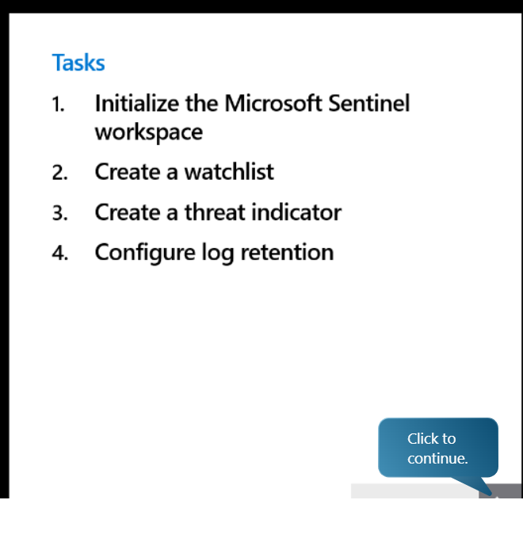

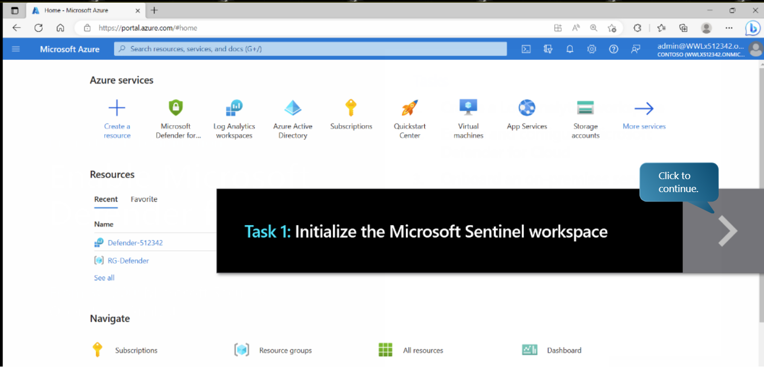

Next type Microsoft sentinel into the search engine

After selecting sentinel your going to click “***create***”

Next click the log analytics workspace and click add from your defender

1st step is to open note pad

